65.12.15b
Transfer of Title
Archival location?, SA.

(C)
CERTIFICATE OF TITLE
Register Book
Vol. XLV Folio. 194

Ferdinand Jacob Heinrich Müller of Melbourne in the Province of Victoria is now seised of an estate in fee simple subject nevertheless to such encumbrances liens and interests as are notified by memorial underwritten or endorsed hereon in That piece of land situated in The Hundred of Moorooroo County of Light being the allotment 11 of the section 39 laid out as the Village of Tanunda and bounded as appears in the plan deposited in the General Registry Office No. 234 of 1854 and in the plan in the margin hereof and therein colored green Which said piece of land contains three roods and twenty eight perches or thereabouts and measures on the northerly side next Young Street two chains and six links or thereabouts on the southerly side next Jane Place two chains and five links or thereabouts on the easterly side next the allotment 12 four chains and forty nine links or thereabouts and on the westerly side next the allotment 10 four chains and fifty three links or thereabouts Which said section is delineated in the Public map of the said Hundred deposited in the Office of the Surveyor General and was originally granted the thirty first day of May 1842 under the hand and seal of George Grey Esquire Resident Commissioner and Governor of the said Province to Charles Flaxman

In witness whereof, I have hereunto signed my name and affixed my seal this thirteenth day of November one thousand eight hundred and sixty three
W B T Andrews
Acting Registrar-General

Signed, the 13th day of Novr 1863 in presence of H P Denton

Transfer No. 12420 dated the 5 day Decr. 1865 produced the 15 day Dec. 1865 at Ten o'clock a.m. from the above named Ferdinand Jacob Heinrich Müller to Julius Pabst of Tanunda Surgeon of the above land Consideration money paid £17. 10/'..

Entered the 15 day Dec 1865 at Ten o'clock a.m.
W Bacon Carter Dep. Registrar General
This Certificate of Title is cancelled and a new Certificate of Title is issued Vol. LXXVII Folio 97
W B T Andrews Registrar-General

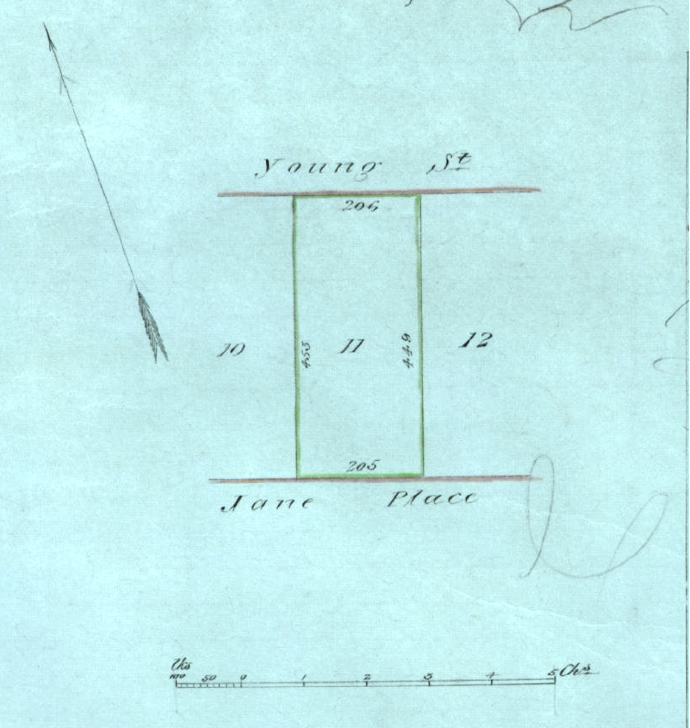

Document headed by coat of arms of SA. MS bears a pencilled tick and an annotation: '4410'.
The seal of the 'Registrar General South Australia' is next to the signature.
The plan of the land described is below this signature see 65-12-15b_image01.jpg.

